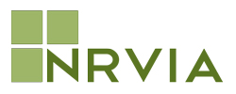

The National Recreational Vehicle Inspectors Association or NRVIA is a professional RV inspector membership organization. Membership in the NRVIA is voluntary and its members are RV Inspectors and industry affiliates whose purpose is to promote excellence in the profession and continued improvement of its members’ inspection services to the public.
Use of the NRVIA logo and name is limited to those members of good standing who may utilize this logo and name in their professional promotions and advertising.
The NRVIA designation of Certified RV Inspector is permitted only to be use by those individuals that have met the requirements and testing standards established by NRVIA.

